**PaperCut Student Install Instructions**

Before installing the PaperCut client and student print queues, open the **Credential Manager** app. Then click the “**Add a Windows Credential**” link. You will enter three sets of credentials.

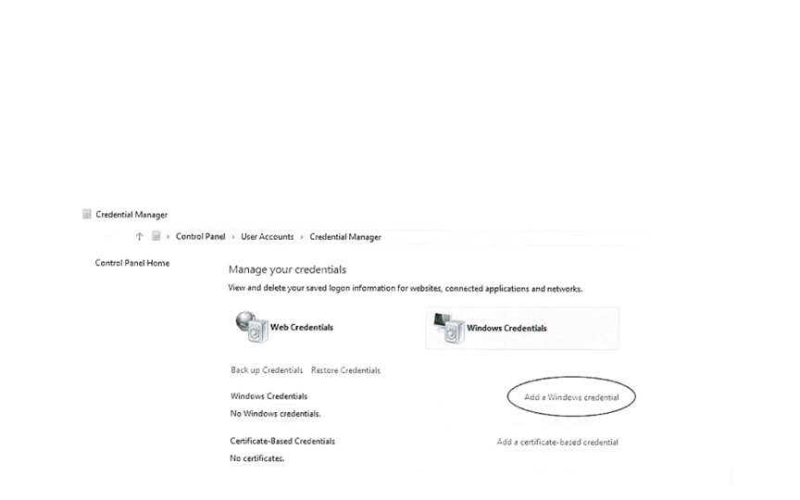

Enter the server address, student number, and password. The server address will be: \\papercut2.ad.gtc.edu

The student number will be in the form: studentnumber@ad.gtc.edu

The student’s password will be the password from your Gateway email or Blackboard.

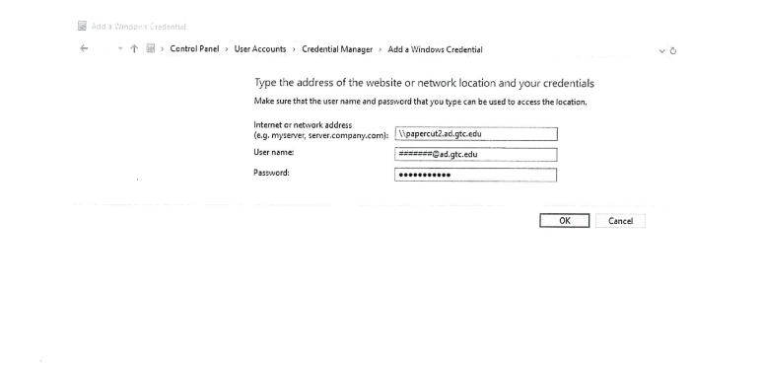

Then click the “**Add a Windows Credential**” link again.

Enter the server address, student number, and password. The server address will be: **\\kcadmin.ad.gtc.edu**

The student number will be in the form: studentnumber@ad.gtc.edu

The student’s password will be the password from your Gateway email or Blackboard.

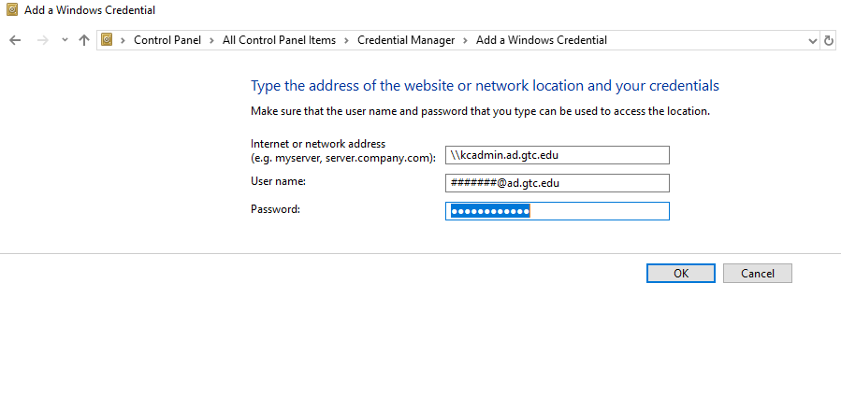

Then click the “**Add a Windows Credential**” link again. Enter the server address, student number, and password. The server address will be: **\\hpadmin.ad.gtc.edu**

The student number will be in the form: studentnumber@ad.gtc.edu

The student’s password will be the password from your Gateway email or Blackboard.

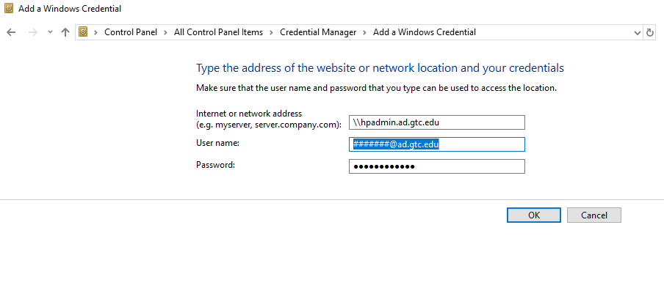

After the Credentials have been setup, open a **Windows Explorer** and proceed to the server “**\\papercut2.ad.gtc.edu\PCClient\win**” folder and double-click “**client-local-install.exe**” to install the PaperCut client.

**Windows Explorer**



Type in **\\papercut2.ad.gtc.edu\PCClient\win** where it reads “This PC > Documents”.

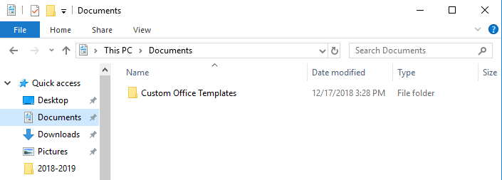

Click on the Papercut logo that reads as **PC-Client** the file type should be application.

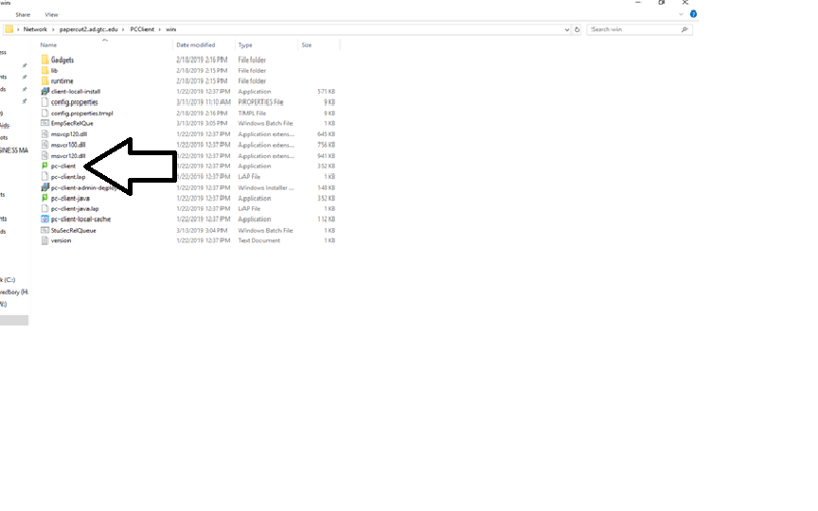

Select Run

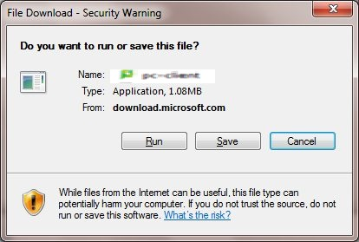

After the PaperCut client is installed, enter the student number (without @ad.gtc.edu) and password in the login box popup and check the “Remember my identity” box. Click “OK”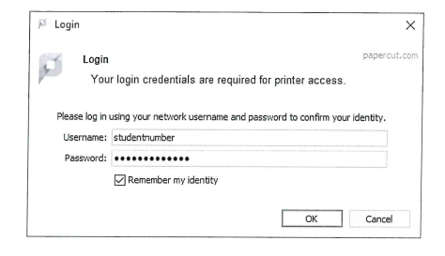

Next type in **\\kcadmin.ad.gtc.edu** where it reads “This PC > Documents.” This location has the driver install files for the Kyocera release stations.

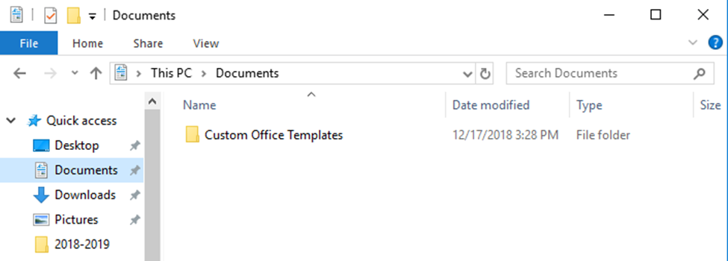

Then look for the **BW_KC_Student_Secure Release** Printer and the **Color_KC_Student_Secure Release** Printer. Double-click on each to install the driver for each.

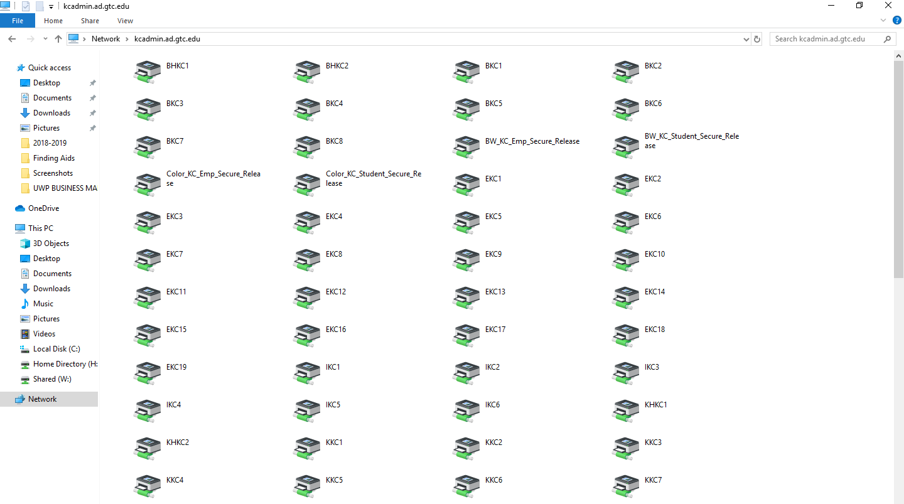

Next type in **\\hpadmin.ad.gtc.edu** where it reads “This PC > Documents.” This location has the driver install files for the Hewlett-Packard (HP) release stations.

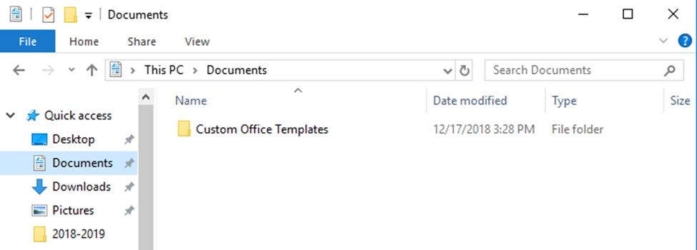

Then look for the **BW_HP_Student_Secure Release** Printer and the **Color_HP_Student_Secure Release** Printer.

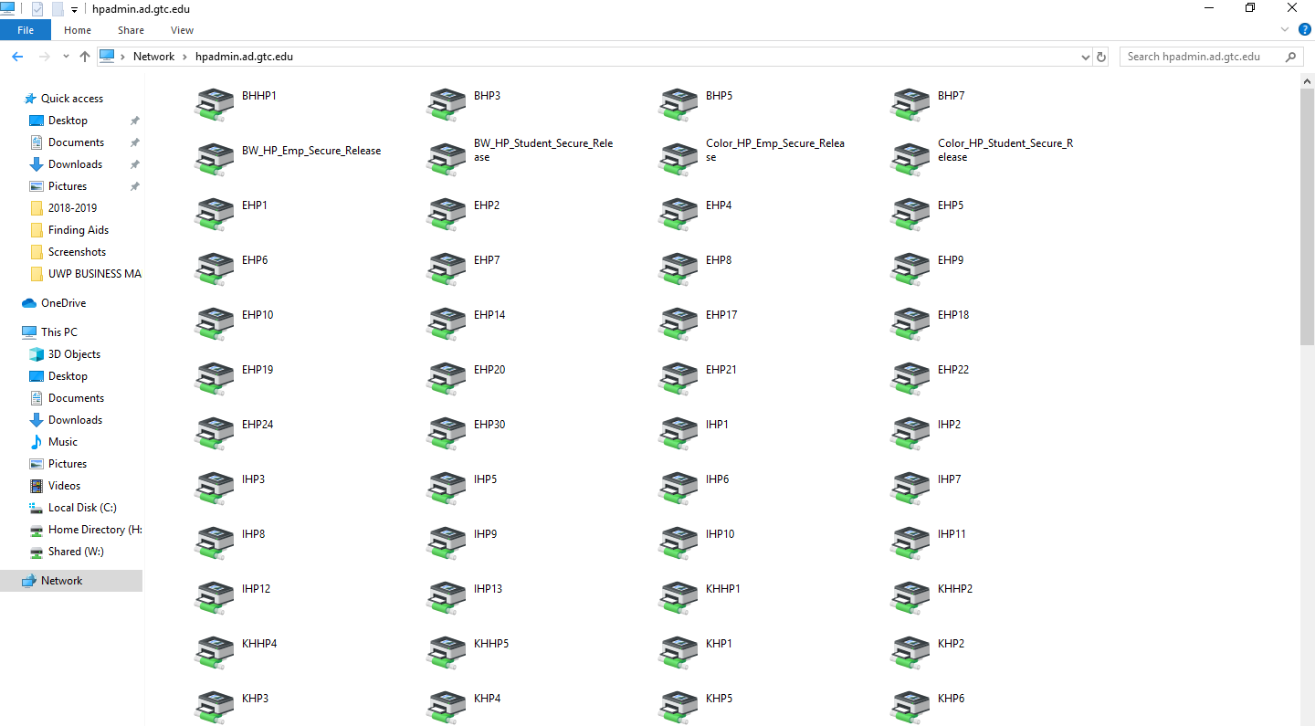

Wait for a pop up, once the pop up is up you have finish downloading the drivers and you are all done.